«Astana IT University» ЖШС Колледжі

Web - сайттың құрылымын әзірлеу пәні
ПРАКТИКАЛЫҚ ЖҰМЫС №3
DOM арқылы интерактивті басқару панелі

Тобы: БҚ2404
Студенттің аты-жөні: Сағындық Р.А.
Пән оқытушысы: Таңжарбаева М.А.

Астана 2026 ж

HTML:

Login.html:

<!DOCTYPE html>
<html lang="kk">
<head>
<meta charset="UTF-8">
<meta name="viewport" content="width=device-width, initial-scale=1.0">
<title>Кіру</title>
<link rel="stylesheet" href="style.css">
</head>
<body>
<div class="container">
<h3>Жүйеге кіру</h3>
<div id="messageArea"></div>
<form id="loginForm">
<label for="loginUsername">Пайдаланушы аты (username):</label>
<input type="text" id="loginUsername" required>
<label for="loginPassword">Құпиясөз:</label>
<input type="password" id="loginPassword" required>
<button type="submit">Кіру</button>
</form>
<p class="link">Тіркелмегенсіз бе? <a href="register.html">Тіркелу</a></p>
</div>
<script src="auth.js"></script>
</body>
</html>

Register.html:

<!DOCTYPE html>
<html lang="kk">
<head>
<meta charset="UTF-8">
<meta name="viewport" content="width=device-width, initial-scale=1.0">
<title>Тіркелу</title>
<link rel="stylesheet" href="style.css">
</head>
<body>
<div class="container">
<h3>Тіркелу</h3>
<div id="messageArea"></div>
<form id="registerForm">
<label for="fname">Атыңызды енгізіңіз:</label>
<input type="text" id="fname" placeholder="Атыңыз" required>
<label for="lname">Тегіңізді енгізіңіз:</label>
<input type="text" id="lname" placeholder="Тегіңіз" required>
<label for="username">Пайдаланушы аты (username):</label>
<input type="text" id="username" placeholder="username123" required>
<label>Жынысыңыз:</label>
<div class="radio-group">
<label><input type="radio" name="gender" value="male" required> Ер</label>
<label><input type="radio" name="gender" value="female" required> Әйел</label>
</div>
<label for="DoB">Туған күніңіз:</label>
<input type="date" id="DoB" required>
<label for="phone_number">Телефон нөмірі:</label>
<input type="tel" id="phone_number" placeholder="+7 (___) ___-__-__" required>
<label for="email">Электронды пошта:</label>
<input type="email" id="email" placeholder="example@gmail.com" required>
<label for="password">Құпиясөз:</label>
<input type="password" id="password" placeholder="Құпиясөз" required>
<div class="checkbox-group">
<label><input type="checkbox" id="show_password"> Көрсету</label>
</div>
<label for="confirm_password">Құпиясөзді қайталаңыз:</label>
<input type="password" id="confirm_password" placeholder="Құпиясөзді қайталаңыз" required>
<label for="role">Рөліңізді таңдаңыз:</label>
<select id="role" required>
<option value="">-- Таңдаңыз --</option>
<option value="User">Пайдаланушы</option>
<option value="Admin">Администратор</option>
<option value="Guest">Қонақ</option>
</select>
<div class="checkbox-group">
<label><input type="checkbox" id="confirmpolicy" required> Пайдаланушы келісімдерін растаймын</label>
</div>
<button type="submit">Тіркелу</button>
</form>
<p class="link">Тіркелдіңіз бе? <a href="login.html">Кіру</a></p>
</div>
<script src="auth.js"></script>
</body>
</html>

Dashboard.html:

<!DOCTYPE html>
<html lang="kk">
<head>
<meta charset="UTF-8">
<meta name="viewport" content="width=device-width, initial-scale=1.0">
<title>Басты бет</title>
<link rel="stylesheet" href="style.css">
</head>
<body>
<div class="header">
<h3 id="userName"></h3>
<button id="logoutBtn">Шығу</button>
</div>
<div class="container">
<div id="messageArea"></div>
<div id="adminPanel" class="panel hidden">
<h3>Пайдаланушыларды басқару</h3>
<div class="controls">
<input type="text" id="searchInput" placeholder="Іздеу...">
<select id="filterRole">
<option value="">Барлық рөлдер</option>
<option value="Admin">Admin</option>
<option value="User">User</option>
<option value="Guest">Guest</option>
</select>
<button id="refreshBtn">Жаңарту</button>
</div>
<table id="usersTable">
<thead>
<tr>
<th>№</th>
<th>Аты</th>
<th>Тегі</th>
<th>Email</th>
<th>Телефон</th>
<th>Жынысы</th>
<th>Туған күні</th>
<th>Рөлі</th>
<th>Әрекет</th>
</tr>
</thead>
<tbody id="usersTableBody">
</tbody>
</table>
</div>
<div id="userPanel" class="panel hidden">
<h3>Математикалық калькуляторлар</h3>
<div class="calc-section">
<h4>Күрделі пайыз калькуляторы</h4>
<label>Бастапқы сома:</label>
<input type="number" id="principal" placeholder="10000">
<label>Жылдық пайыз (%):</label>
<input type="number" id="rate" placeholder="5" step="0.01">
<label>Мерзімі (жыл):</label>
<input type="number" id="time" placeholder="5">
<label>Есептелу жиілігі (жылына):</label>
<select id="frequency">
<option value="1">Жылына 1 рет</option>
<option value="4">Тоқсанына 1 рет</option>
<option value="12">Айына 1 рет</option>
<option value="365">Күнделікті</option>
</select>
<button id="calcCompound">Есептеу</button>
<div id="compoundResult" class="result"></div>
</div>
<div class="calc-section">
<h4>Комбинаторика</h4>
<label>n мәні:</label>
<input type="number" id="combN" placeholder="10" min="0">
<label>r мәні:</label>
<input type="number" id="combR" placeholder="3" min="0">
<button id="calcPermutation">Орналастыру P(n,r)</button>
<button id="calcCombination">Теру C(n,r)</button>
<div id="combResult" class="result"></div>
</div>
<div class="calc-section">
<h4>Матрица операциялары (2x2)</h4>
<label>Матрица A:</label>
<div class="matrix-input">
<input type="number" id="a11" placeholder="1">
<input type="number" id="a12" placeholder="2">
<input type="number" id="a21" placeholder="3">
<input type="number" id="a22" placeholder="4">
</div>
<label>Матрица B:</label>
<div class="matrix-input">
<input type="number" id="b11" placeholder="5">
<input type="number" id="b12" placeholder="6">
<input type="number" id="b21" placeholder="7">
<input type="number" id="b22" placeholder="8">
</div>
<button id="calcMatrixAdd">Қосу A+B</button>
<button id="calcMatrixMult">Көбейту A×B</button>
<button id="calcDeterminant">Детерминант A</button>
<div id="matrixResult" class="result"></div>
</div>
<div class="calc-section">
<h4>НОД және НОК</h4>
<label>Бірінші сан:</label>
<input type="number" id="gcdNum1" placeholder="48" min="1">
<label>Екінші сан:</label>
<input type="number" id="gcdNum2" placeholder="18" min="1">
<button id="calcGCD">НОД (ең үлкен ортақ бөлгіш)</button>
<button id="calcLCM">НОК (ең кіші ортақ еселік)</button>
<div id="gcdLcmResult" class="result"></div>
</div>
<div class="calc-section">
<h4>Факториал және жай сандар</h4>
<label>Сан:</label>
<input type="number" id="factNum" placeholder="5" min="0">
<button id="calcFactorial">Факториал n!</button>
<button id="checkPrime">Жай санды тексеру</button>
<div id="factResult" class="result"></div>
</div>
<div class="calc-section">
<h4>Қарапайым калькулятор</h4>
<input type="number" id="num1" placeholder="Бірінші сан">
<select id="operation">
<option value="+">+</option>
<option value="-">−</option>
<option value="*">×</option>
<option value="/">÷</option>
<option value="^">^</option>
<option value="%">%</option>
</select>
<input type="number" id="num2" placeholder="Екінші сан">
<button id="calcSimple">Есептеу</button>
<div id="simpleResult" class="result"></div>
</div>
</div>
<div id="guestPanel" class="panel hidden">
<h3>Қонақ режимі</h3>
<p>Сізде шектеулі қолжетімділік бар. Толық мүмкіндіктер үшін тіркелу қажет.</p>
<div class="calc-section">
<h4>Қарапайым калькулятор</h4>
<input type="number" id="guestNum1" placeholder="Бірінші сан">
<select id="guestOperation">
<option value="+">+</option>
<option value="-">−</option>
<option value="*">×</option>
<option value="/">÷</option>
</select>
<input type="number" id="guestNum2" placeholder="Екінші сан">
<button id="calcGuestSimple">Есептеу</button>
<div id="guestResult" class="result"></div>
</div>
</div>
</div>
<script src="dashboard.js"></script>
</body>
</html>

CSS:

* {
margin: 0;
padding: 0;
box-sizing: border-box;
}
body {
font-family: 'Courier New', monospace;
background-color: #e0e0e0;
color: #000;
}
.container {
max-width: 900px;
margin: 20px auto;
background-color: #fff;
border: 1px solid #000;
padding: 20px;
}
.header {
background-color: #000;
color: #fff;
padding: 10px 20px;
display: flex;
justify-content: space-between;
align-items: center;
}
h3,
h4 {
margin-bottom: 15px;
font-weight: normal;
border-bottom: 1px solid #000;
padding-bottom: 5px;
}
label {
display: block;
margin-top: 10px;
margin-bottom: 3px;
font-size: 14px;
}
input[type="text"],
input[type="email"],
input[type="password"],
input[type="tel"],
input[type="date"],
input[type="number"],
select {
width: 100%;
padding: 8px;
border: 1px solid #000;
background-color: #fff;
font-family: 'Courier New', monospace;
font-size: 14px;
margin-bottom: 10px;
}
input:focus,
select:focus {
outline: 2px solid #000;
outline-offset: -2px;
}
.radio-group,
.checkbox-group {
margin: 10px 0;
}
.radio-group label,
.checkbox-group label {
display: inline-block;
margin-right: 15px;
margin-top: 0;
}
button {
padding: 10px 20px;
background-color: #000;
color: #fff;
border: none;
cursor: pointer;
font-family: 'Courier New', monospace;
font-size: 14px;
margin: 5px 5px 5px 0;
}
button:hover {
background-color: #333;
}
button:active {
background-color: #666;
}
.link {
margin-top: 15px;
text-align: center;
}
.link a {
color: #000;
text-decoration: underline;
}
#messageArea {
padding: 10px;
margin-bottom: 15px;
border: 1px solid #000;
display: none;
}
#messageArea.show {
display: block;
}
#messageArea.error {
background-color: #ffcccc;
}
#messageArea.success {
background-color: #ccffcc;
}
#messageArea.warning {
background-color: #ffffcc;
}
table {
width: 100%;
border-collapse: collapse;
margin-top: 15px;
}
table th,
table td {
border: 1px solid #000;
padding: 8px;
text-align: left;
font-size: 13px;
}
table th {
background-color: #000;
color: #fff;
font-weight: normal;
}
table tr:nth-child(even) {
background-color: #f0f0f0;
}
.controls {
display: flex;
gap: 10px;
margin-bottom: 15px;
}
.controls input,
.controls select {
flex: 1;
margin-bottom: 0;
}
.controls button {
flex: 0;
}
.panel {
display: block;
}
.panel.hidden {
display: none;
}
.calc-section {
border: 1px solid #000;
padding: 15px;
margin-bottom: 20px;
}
.calc-section h4 {
margin-top: 0;
}
.result {
margin-top: 10px;
padding: 10px;
border: 1px solid #000;
background-color: #f9f9f9;
font-weight: bold;
min-height: 20px;
}
.matrix-input {
display: grid;
grid-template-columns: 1fr 1fr;
gap: 5px;
margin-bottom: 10px;
}
.matrix-input input {
margin-bottom: 0;
}

JavaScript:

Auth.js:

document.addEventListener('DOMContentLoaded', function () {
const messageArea = document.getElementById('messageArea');
const USERS_KEY = 'users';
const CURRENT_USER_KEY = 'currentUser';
function showMessage(message, type) {
messageArea.textContent = message;
messageArea.className = 'show ' + type;
setTimeout(() => {
messageArea.classList.remove('show');
}, 3000);
}
function getUsers() {
const users = localStorage.getItem(USERS_KEY);
return users ? JSON.parse(users) : [];
}
function saveUsers(users) {
localStorage.setItem(USERS_KEY, JSON.stringify(users));
}
const registerForm = document.getElementById('registerForm');
if (registerForm) {
const showPasswordCheckbox = document.getElementById('show_password');
const passwordInput = document.getElementById('password');
const confirmPasswordInput = document.getElementById('confirm_password');
if (showPasswordCheckbox) {
showPasswordCheckbox.addEventListener('change', function () {
const type = this.checked ? 'text' : 'password';
passwordInput.type = type;
confirmPasswordInput.type = type;
});
}
registerForm.addEventListener('submit', function (e) {
e.preventDefault();
const fname = document.getElementById('fname').value.trim();
const lname = document.getElementById('lname').value.trim();
const username = document.getElementById('username').value.trim();
const email = document.getElementById('email').value.trim();
const password = passwordInput.value;
const confirmPassword = confirmPasswordInput.value;
const phone = document.getElementById('phone_number').value.trim();
const dob = document.getElementById('DoB').value;
const role = document.getElementById('role').value;
const policy = document.getElementById('confirmpolicy').checked;
let gender = '';
const genderInputs = document.getElementsByName('gender');
for (let input of genderInputs) {
if (input.checked) {
gender = input.value;
break;
}
}
const users = getUsers();
if (fname.length < 3) {
showMessage('Аты кемінде 3 символ болуы керек', 'error');
return;
}
if (lname.length < 3) {
showMessage('Тегі кемінде 3 символ болуы керек', 'error');
return;
}
if (username.length < 3) {
showMessage('Username кемінде 3 символ болуы керек', 'error');
return;
}
const usernameExists = users.find(u => u.username && u.username === username);
if (usernameExists) {
showMessage('Бұл username тіркелген', 'error');
return;
}
const emailExists = users.find(u => u.email === email);
if (emailExists) {
showMessage('Бұл email тіркелген', 'error');
return;
}
if (password.length < 8) {
showMessage('Құпиясөз кемінде 8 символ болуы керек', 'error');
return;
}
const hasNumberOrSpecial = /[0-9!@#$%^&*()_+\-=\[\]{};':"\\|,.<>\/?]/.test(password);
if (!hasNumberOrSpecial) {
showMessage('Құпиясөзде цифр немесе арнайы символдар болуы керек', 'error');
return;
}
if (password !== confirmPassword) {
showMessage('Құпиясөздер сәйкес емес', 'error');
return;
}
if (!policy) {
showMessage('Келісімді растау қажет', 'error');
return;
}
if (emailExists) {
showMessage('Бұл email тіркелген', 'error');
return;
}
const newUser = {
fname,
lname,
username,
email,
password,
phone,
dob,
role,
gender
};
users.push(newUser);
saveUsers(users);
showMessage('Тіркелу сәтті! Кіру бетіне өтесіз...', 'success');
setTimeout(() => {
window.location.href = 'login.html';
}, 1500);
});
}
const loginForm = document.getElementById('loginForm');
if (loginForm) {
loginForm.addEventListener('submit', function (e) {
e.preventDefault();
const username = document.getElementById('loginUsername').value.trim();
const password = document.getElementById('loginPassword').value;
const users = getUsers();
const user = users.find(u => u.username && u.username === username && u.password === password);
if (user) {
localStorage.setItem(CURRENT_USER_KEY, JSON.stringify(user));
showMessage('Кіру сәтті! Басты бетке өтесіз...', 'success');
setTimeout(() => {
window.location.href = 'dashboard.html';
}, 1000);
} else {
showMessage('Username немесе құпиясөз қате', 'error');
}
});
}
});

Dashboard.js:

document.addEventListener('DOMContentLoaded', function () {
const messageArea = document.getElementById('messageArea');
const CURRENT_USER_KEY = 'currentUser';
const USERS_KEY = 'users';
const currentUserData = localStorage.getItem(CURRENT_USER_KEY);
if (!currentUserData) {
window.location.href = 'login.html';
return;
}
const currentUser = JSON.parse(currentUserData);
document.getElementById('userName').textContent = `${currentUser.fname} ${currentUser.lname} (${currentUser.role})`;
document.getElementById('logoutBtn').addEventListener('click', function () {
localStorage.removeItem(CURRENT_USER_KEY);
window.location.href = 'login.html';
});
function showMessage(message, type) {
messageArea.textContent = message;
messageArea.className = 'show ' + type;
setTimeout(() => {
messageArea.classList.remove('show');
}, 3000);
}
const adminPanel = document.getElementById('adminPanel');
const userPanel = document.getElementById('userPanel');
const guestPanel = document.getElementById('guestPanel');
if (currentUser.role === 'Admin') {
adminPanel.classList.remove('hidden');
initAdminPanel();
} else if (currentUser.role === 'User') {
userPanel.classList.remove('hidden');
initUserPanel();
} else if (currentUser.role === 'Guest') {
guestPanel.classList.remove('hidden');
initGuestPanel();
}
function initAdminPanel() {
const usersTableBody = document.getElementById('usersTableBody');
const searchInput = document.getElementById('searchInput');
const filterRole = document.getElementById('filterRole');
const refreshBtn = document.getElementById('refreshBtn');
function getUsers() {
const users = localStorage.getItem(USERS_KEY);
return users ? JSON.parse(users) : [];
}
function renderTable(users) {
usersTableBody.innerHTML = '';
users.forEach((user, index) => {
const row = document.createElement('tr');
row.innerHTML = `
<td>${index + 1}</td>
<td>${user.fname}</td>
<td>${user.lname}</td>
<td>${user.email}</td>
<td>${user.phone}</td>
<td>${user.gender === 'male' ? 'Ер' : 'Әйел'}</td>
<td>${user.dob}</td>
<td>${user.role}</td>
<td><button class="deleteBtn" data-index="${index}">Өшіру</button></td>
`;
usersTableBody.appendChild(row);
});
const deleteBtns = document.querySelectorAll('.deleteBtn');
deleteBtns.forEach(btn => {
btn.addEventListener('click', function () {
const index = parseInt(this.dataset.index);
deleteUser(index);
});
});
}
function deleteUser(index) {
const users = getUsers();
users.splice(index, 1);
localStorage.setItem(USERS_KEY, JSON.stringify(users));
filterAndRenderUsers();
showMessage('Пайдаланушы өшірілді', 'success');
}
function filterAndRenderUsers() {
let users = getUsers();
const searchTerm = searchInput.value.toLowerCase();
const roleFilter = filterRole.value;
if (searchTerm) {
users = users.filter(u =>
u.fname.toLowerCase().includes(searchTerm) ||
u.lname.toLowerCase().includes(searchTerm) ||
u.email.toLowerCase().includes(searchTerm)
);
}
if (roleFilter) {
users = users.filter(u => u.role === roleFilter);
}
renderTable(users);
}
searchInput.addEventListener('input', filterAndRenderUsers);
filterRole.addEventListener('change', filterAndRenderUsers);
refreshBtn.addEventListener('click', filterAndRenderUsers);
filterAndRenderUsers();
}
function initUserPanel() {
document.getElementById('calcCompound').addEventListener('click', function () {
const P = parseFloat(document.getElementById('principal').value);
const r = parseFloat(document.getElementById('rate').value) / 100;
const t = parseFloat(document.getElementById('time').value);
const n = parseFloat(document.getElementById('frequency').value);
if (isNaN(P) || isNaN(r) || isNaN(t) || isNaN(n)) {
document.getElementById('compoundResult').textContent = 'Барлық өрістерді толтырыңыз';
return;
}
const A = P * Math.pow(1 + r / n, n * t);
const interest = A - P;
document.getElementById('compoundResult').innerHTML = `
Қорытынды сома: ${A.toFixed(2)} ₸<br>
Пайыз: ${interest.toFixed(2)} ₸
`;
});
document.getElementById('calcPermutation').addEventListener('click', function () {
const n = parseInt(document.getElementById('combN').value);
const r = parseInt(document.getElementById('combR').value);
if (isNaN(n) || isNaN(r) || n < 0 || r < 0 || r > n) {
document.getElementById('combResult').textContent = 'Қате мәндер';
return;
}
const result = factorial(n) / factorial(n - r);
document.getElementById('combResult').textContent = `P(${n},${r}) = ${result}`;
});
document.getElementById('calcCombination').addEventListener('click', function () {
const n = parseInt(document.getElementById('combN').value);
const r = parseInt(document.getElementById('combR').value);
if (isNaN(n) || isNaN(r) || n < 0 || r < 0 || r > n) {
document.getElementById('combResult').textContent = 'Қате мәндер';
return;
}
const result = factorial(n) / (factorial(r) * factorial(n - r));
document.getElementById('combResult').textContent = `C(${n},${r}) = ${result}`;
});
document.getElementById('calcMatrixAdd').addEventListener('click', function () {
const a11 = parseFloat(document.getElementById('a11').value) || 0;
const a12 = parseFloat(document.getElementById('a12').value) || 0;
const a21 = parseFloat(document.getElementById('a21').value) || 0;
const a22 = parseFloat(document.getElementById('a22').value) || 0;
const b11 = parseFloat(document.getElementById('b11').value) || 0;
const b12 = parseFloat(document.getElementById('b12').value) || 0;
const b21 = parseFloat(document.getElementById('b21').value) || 0;
const b22 = parseFloat(document.getElementById('b22').value) || 0;
document.getElementById('matrixResult').innerHTML = `
A + B = <br>
[${a11 + b11}, ${a12 + b12}]<br>
[${a21 + b21}, ${a22 + b22}]
`;
});
document.getElementById('calcMatrixMult').addEventListener('click', function () {
const a11 = parseFloat(document.getElementById('a11').value) || 0;
const a12 = parseFloat(document.getElementById('a12').value) || 0;
const a21 = parseFloat(document.getElementById('a21').value) || 0;
const a22 = parseFloat(document.getElementById('a22').value) || 0;
const b11 = parseFloat(document.getElementById('b11').value) || 0;
const b12 = parseFloat(document.getElementById('b12').value) || 0;
const b21 = parseFloat(document.getElementById('b21').value) || 0;
const b22 = parseFloat(document.getElementById('b22').value) || 0;
const c11 = a11 * b11 + a12 * b21;
const c12 = a11 * b12 + a12 * b22;
const c21 = a21 * b11 + a22 * b21;
const c22 = a21 * b12 + a22 * b22;
document.getElementById('matrixResult').innerHTML = `
A × B = <br>
[${c11}, ${c12}]<br>
[${c21}, ${c22}]
`;
});
document.getElementById('calcDeterminant').addEventListener('click', function () {
const a11 = parseFloat(document.getElementById('a11').value) || 0;
const a12 = parseFloat(document.getElementById('a12').value) || 0;
const a21 = parseFloat(document.getElementById('a21').value) || 0;
const a22 = parseFloat(document.getElementById('a22').value) || 0;
const det = a11 * a22 - a12 * a21;
document.getElementById('matrixResult').textContent = `det(A) = ${det}`;
});
document.getElementById('calcGCD').addEventListener('click', function () {
const a = parseInt(document.getElementById('gcdNum1').value);
const b = parseInt(document.getElementById('gcdNum2').value);
if (isNaN(a) || isNaN(b) || a <= 0 || b <= 0) {
document.getElementById('gcdLcmResult').textContent = 'Оң сандарды енгізіңіз';
return;
}
const result = gcd(a, b);
document.getElementById('gcdLcmResult').textContent = `НОД(${a}, ${b}) = ${result}`;
});
document.getElementById('calcLCM').addEventListener('click', function () {
const a = parseInt(document.getElementById('gcdNum1').value);
const b = parseInt(document.getElementById('gcdNum2').value);
if (isNaN(a) || isNaN(b) || a <= 0 || b <= 0) {
document.getElementById('gcdLcmResult').textContent = 'Оң сандарды енгізіңіз';
return;
}
const result = lcm(a, b);
document.getElementById('gcdLcmResult').textContent = `НОК(${a}, ${b}) = ${result}`;
});
document.getElementById('calcFactorial').addEventListener('click', function () {
const n = parseInt(document.getElementById('factNum').value);
if (isNaN(n) || n < 0) {
document.getElementById('factResult').textContent = 'Теріс емес санды енгізіңіз';
return;
}
if (n > 170) {
document.getElementById('factResult').textContent = 'Сан тым үлкен (max 170)';
return;
}
const result = factorial(n);
document.getElementById('factResult').textContent = `${n}! = ${result}`;
});
document.getElementById('checkPrime').addEventListener('click', function () {
const n = parseInt(document.getElementById('factNum').value);
if (isNaN(n) || n < 2) {
document.getElementById('factResult').textContent = '2-ден үлкен санды енгізіңіз';
return;
}
const isPrime = checkPrime(n);
document.getElementById('factResult').textContent = isPrime
? `${n} — жай сан`
: `${n} — құрама сан`;
});
document.getElementById('calcSimple').addEventListener('click', function () {
const num1 = parseFloat(document.getElementById('num1').value);
const num2 = parseFloat(document.getElementById('num2').value);
const op = document.getElementById('operation').value;
if (isNaN(num1) || isNaN(num2)) {
document.getElementById('simpleResult').textContent = 'Сандарды енгізіңіз';
return;
}
let result;
switch (op) {
case '+': result = num1 + num2; break;
case '-': result = num1 - num2; break;
case '*': result = num1 * num2; break;
case '/': result = num2 !== 0 ? num1 / num2 : 'Нөлге бөлуге болмайды'; break;
case '^': result = Math.pow(num1, num2); break;
case '%': result = num1 % num2; break;
}
document.getElementById('simpleResult').textContent = `Нәтиже: ${result}`;
});
}
function initGuestPanel() {
document.getElementById('calcGuestSimple').addEventListener('click', function () {
const num1 = parseFloat(document.getElementById('guestNum1').value);
const num2 = parseFloat(document.getElementById('guestNum2').value);
const op = document.getElementById('guestOperation').value;
if (isNaN(num1) || isNaN(num2)) {
document.getElementById('guestResult').textContent = 'Сандарды енгізіңіз';
return;
}
let result;
switch (op) {
case '+': result = num1 + num2; break;
case '-': result = num1 - num2; break;
case '*': result = num1 * num2; break;
case '/': result = num2 !== 0 ? num1 / num2 : 'Нөлге бөлуге болмайды'; break;
}
document.getElementById('guestResult').textContent = `Нәтиже: ${result}`;
});
}
function factorial(n) {
if (n === 0 || n === 1) return 1;
let result = 1;
for (let i = 2; i <= n; i++) {
result *= i;
}
return result;
}
function gcd(a, b) {
while (b !== 0) {
let temp = b;
b = a % b;
a = temp;
}
return a;
}
function lcm(a, b) {
return (a * b) / gcd(a, b);
}
function checkPrime(n) {
if (n < 2) return false;
if (n === 2) return true;
if (n % 2 === 0) return false;
for (let i = 3; i <= Math.sqrt(n); i += 2) {
if (n % i === 0) return false;
}
return true;
}
});

Тіркелу:

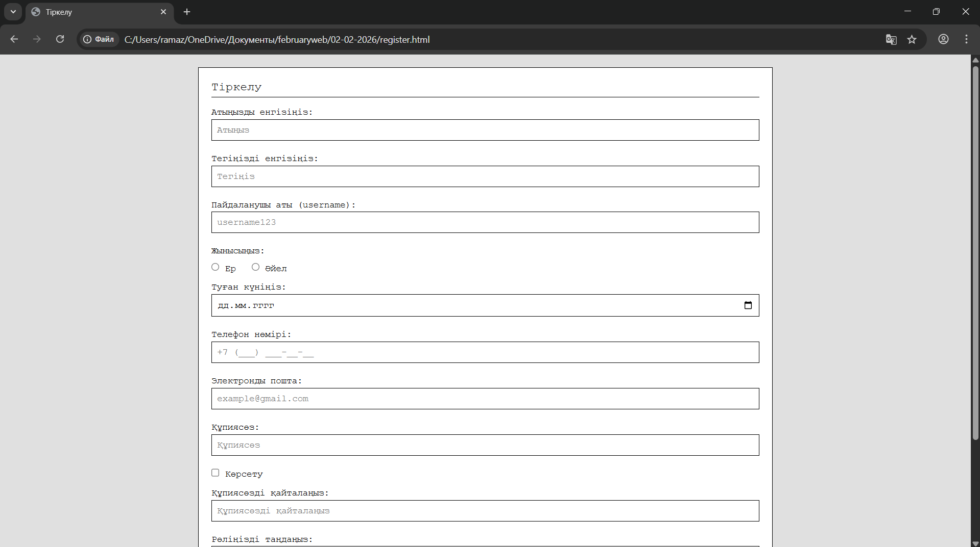


Кіру:

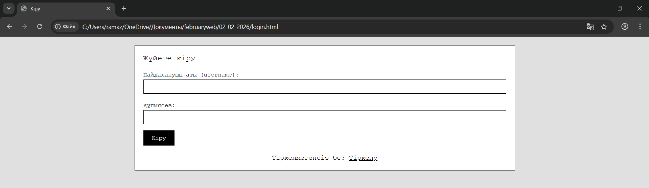

Басты бет (Пайдаланушы):

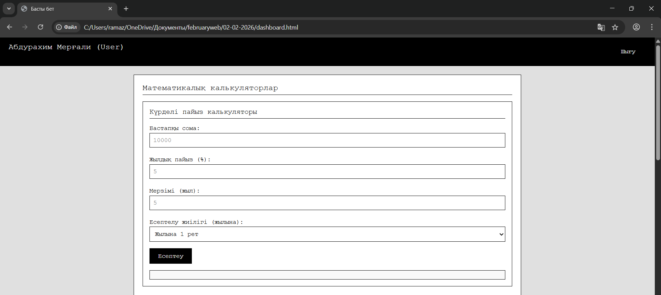
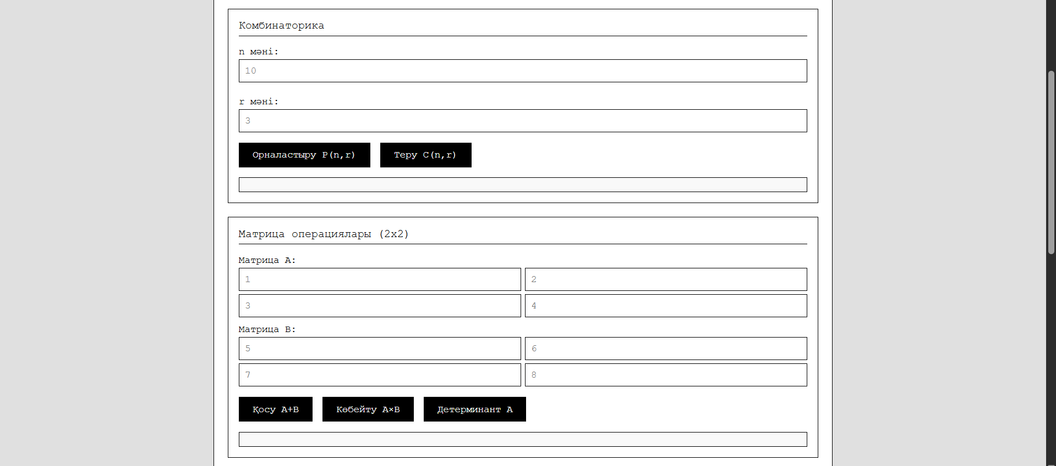
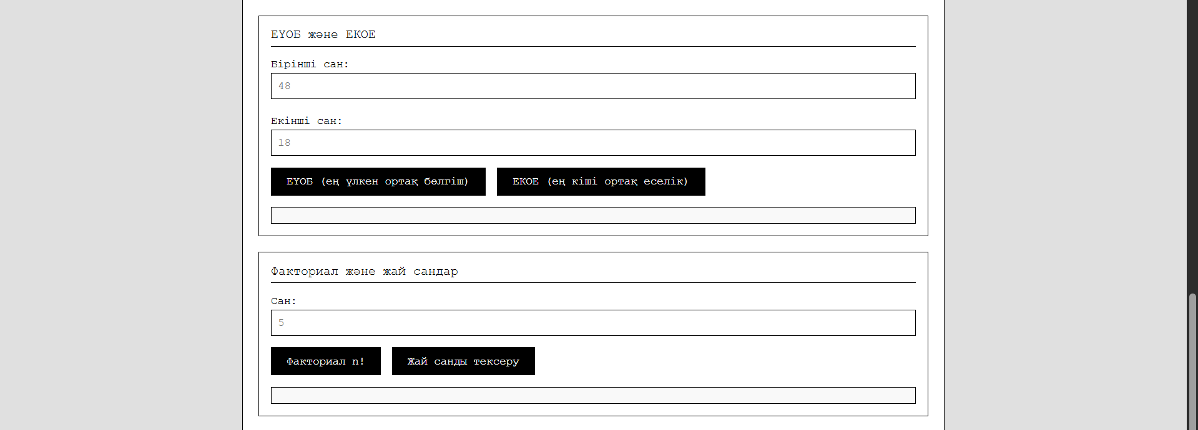
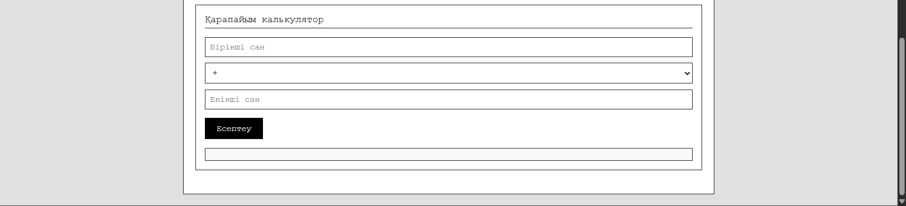

Админ панелі:

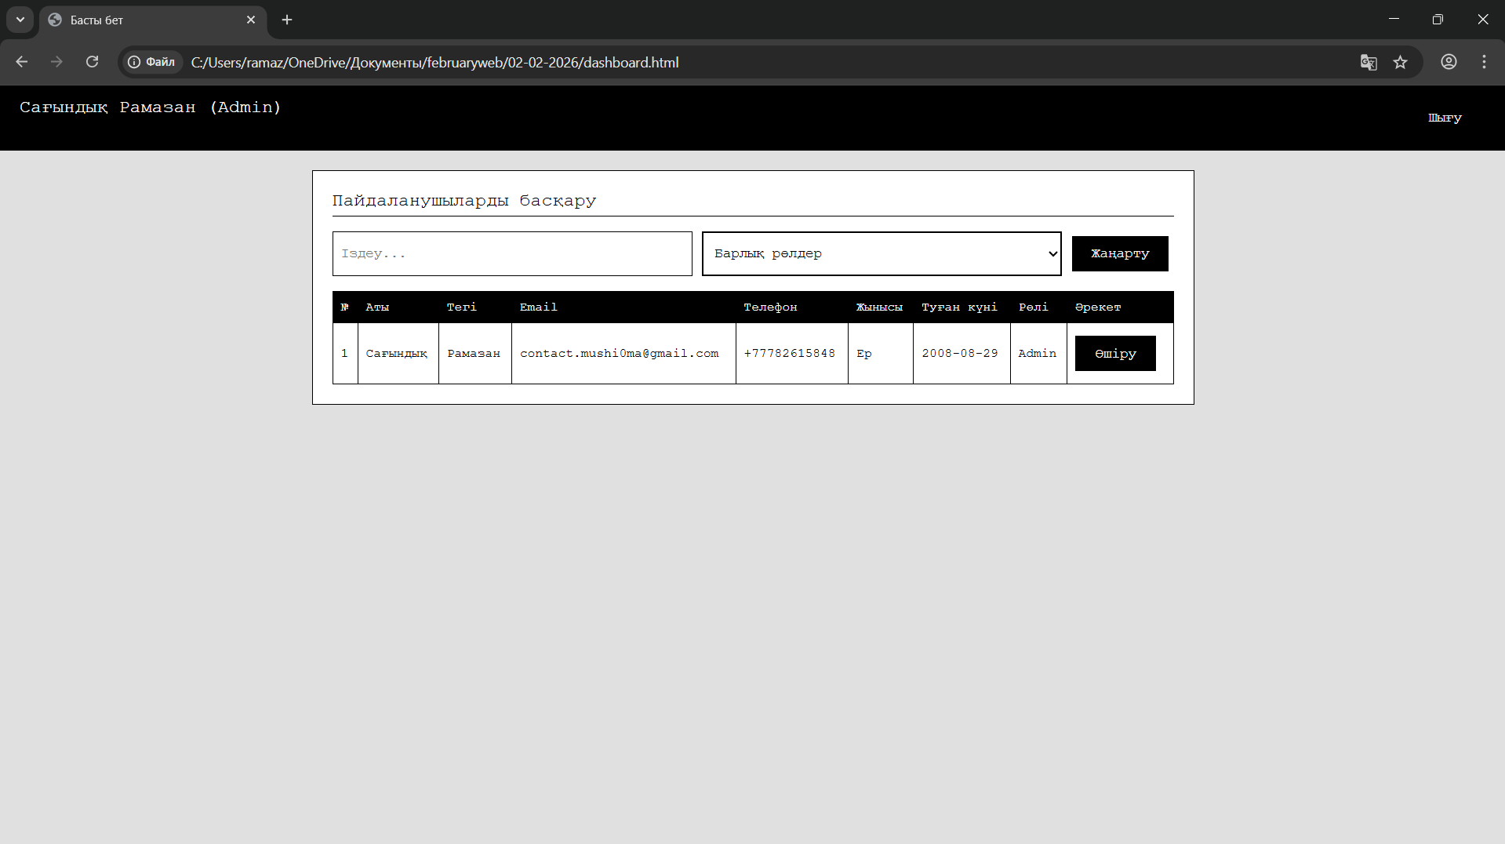

Басты бет (Қонақ):

